REGULATIONS FOR THE APPROVAL OF
DOMESTIC CRICKET

FLOWCHART AND APPLICATION FORM

Effective Date: 1 December 2020

Appendix 1: Flowchart for Sanctioning by USA Cricket of a Domestic Cricket Event

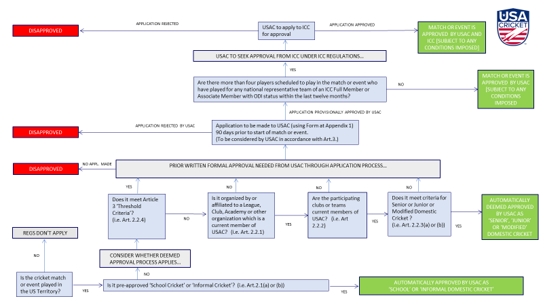

Appendix 2: Application for Sanctioning by USA Cricket of a Domestic Cricket Event
Applicants are requested to please complete the form below and to submit the requested information to Richard Done, the USA Cricket Operations Director, at the following email address: richard.done@usacricket.org

1 | Event Organizer/Promoter  Full details of organizations/individuals involved in the organization of this event and their respective responsibilities (where more than one).
2 | Proposed Event  Proposed name of event, structure and proposed format, i.e. 50 overs, T20 etc.
3 | Proposed Date(s)
4 | Proposed Venue(s)
5 | Participating Teams  Team names and details of the owners of the teams
6 | Participating players  Names of all participating players, the make-up of teams including whether any ‘foreign’ players will be included in the teams and if so, how many and from which countries.
7 | Is the match/event being televised or live streamed?  All relevant details including by whom and in which countries.
8 | How will USA Cricket benefit from staging this event, financially or otherwise?  How will this event will help USA Cricket to achieve its strategic objectives?
9 | If a third party is involved in the organization/promotion of the event, how will the event benefit from its involvement?
10 | What arrangements are in place and who is responsible for the following:
- The payment of players and match officials?
In particular, if and how are such payments guaranteed?

 | - Safety and security risk to participants
 | - COVID-19 risks to participants
 | - Anti-corruption rules and protocols that comply with ICC requirements
 | - The appointment of Match Officials
 | - Player Behavior (Code of Conduct)
 | - Anti-doping rules and protocols that comply with ICC requirements
11 | Details of how the event will be funded Provide a detailed event budget and identify key companies and individuals who are funding the event and the amount they are providing.
12 | Confirmation that no individual who is the subject of a suspension imposed by the ICC or any Member Board shall have any involvement in the organization, promotion or staging of, and shall not participate in the event
16 | Any other comments to be considered in the assessment of the application?

On behalf of the applicant I confirm that:

- the information submitted in this application is true and correct; and
- that until such event has been formally approved by USA Cricket in writing that it will not constitute ‘approved cricket’ under these regulations.

…………………………………………………………………….. ……………………………………………………………………....
Signed Date

……………………………………………………………………… …………………………………………………………..…………..
Name Name of Applicant (if different to the signatory)

