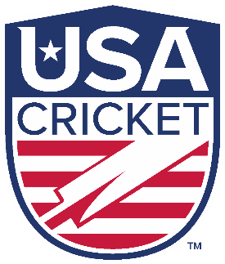
Expression of Interest in Coach Registration/Certification
USA Cricket was established in 2017 to act as the national governing body for the sport of cricket in the United States, and is recognized as an Associate Member of the International Cricket Council. It is a 501(c)(3) charitable nonprofit organization incorporated under the laws of the state of Colorado, but is now headquartered in the San Francisco Bay Area, California. Its mission is to govern, regulate, develop and promote the sport of cricket (including hardball, softball, disabled and all other types of cricket) at all levels in the United States, and to enable United States cricketers to successfully compete in national and international competition.

- Name:

- Mailing address:

- Cell phone:

- Email address:

- Gender:

- Date of birth:

- Age:

- Education:

- Residential status:

- Employment:

Current position:

Current employer:

- Significant contributions to cricket in the USA over the past ten years:

- Highest level of cricket played/coached/involved with:

- Playing experience (including teams/dates – if applicable):

- Coaching credentials held (please list all, together with date acquired – e.g. WICB – 05/05/1998):

- Additional sports that you have coached (and applicable level/credentials, together with date acquired)

- Please list all high-performance coaching experience or events attended

- Total cricket coaching experience (in years)

- USA Cricket Membership (Y/N):

Current member ?

Criminal Background Check Completed ?

- USA sports-related certification:

Concussions in Sports (CDC Youth Sports OR NFHS High School Sports)

First Aid for sports with CPR

Heat Illness Prevention

Sudden Cardiac Arrest

Sportsmanship

Appearance and Performance Enhancing Drugs and Substances

SafeSport

Double Goal Coach - Positive Coaching

- List all other USA sports & health related certificates:

- Please identify all cricket organisations in the USA to which you are currently affiliated / play a role:

- Affiliated League(s) in the USA (if any):

- Affiliated Team(s) in the USA (if any):

- Affiliated Academy or youth program in the USA (if any):

- List all relevant public service awards and other extra recognitions and/or activities (if any)

PLEASE TICK:
I certify that the information submitted is true and correct to the best of my knowledge.

I undertake to abide by all rules, regulations, policies and processes of USA Cricket.

If needed, I will provide all relevant documents to validate any of the information contained herein.

I agree that relevant information from this application can be shared with USA Cricket’s partner, American Cricket Enterprises, for the limited purposes of my being considered for officiating opportunities that may arise within the domestic Minor League and Major League in due course.

Signature:

Date:

